Installing MongoDB, pymongo, ujson (for Windows. Mac OS and Linux may vary)

**MongoDBo installation**

1. Download the version of MongoDB Community Server you need: <https://www.mongodb.com/download-center#community>
2. Choose Custom Install and change the install path to C:\mongodb. Accept all other defaults. The rest of these instructions assume that’s where you’ve installed it.
3. Create folders MongoDB need: (These are the default in MongoDB. You can customize them if you want, but I did not look too close into it. The customer will be managing their own install.)

mkdir c:\data\db

mkdir c:\data\log



1. Start MongoDB up: **You must use a command window with Administrative rights. And this must be done before you try to use our app or Mongo isn’t started and the app can’t use it!**

C:\MongoDB\Server\3.2\bin\mongod.exe



You’ll get a lot of text scrolling. As long as it ends in ‘waiting for connections’ you’re good.



1. Connect to MongoDB to test that it's all working in another cmd window (doesn’t need to be run with admin rights):

C:\MongoDB\Server\3.2\bin\mongo.exe



Ctrl+C to close connection.

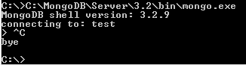

1. If you want to walk through their tutorial for python, you can check it out here: <https://docs.mongodb.com/getting-started/python/> I’ll leave that up to the reader.

**On to pymongo installation**

1. Open a cmd window and install it:

python -m pip install pymongo



1. That’s it.

**On to ujson installation.**

1. Open a cmd window and try to install it:

pip install ujson



1. If you get the error: Unable to find vcvarsall.bat error you will need to do some troubleshooting. It needs to compile some stuff and it is missing Visual Studio’s C++ libraries.
2. **Option 1**: So head on out to <https://www.visualstudio.com/> and download Visual Studio. Make sure you install Common Tools for Visual C++ :

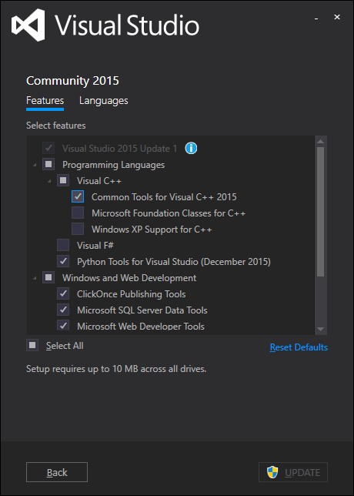

If you are installing ujson for Python 3.5 this is all you need to do.

If you are installing ujson for Pythong 3.4 you’ll also need to run the following command:

set VS100COMNTOOLS=%VS140COMNTOOLS%

Now run the pip install ujson command again.

1. **Option 2**: You can also go try to find the precompiled binary version of ujson and install that instead of dealing with Visual Studio